**Accessing the Superstore Dataset**

There are two ways the class can access the database. The quickest option is accessing via AWS.

However, if the AWS-hosted pgAdmin interface is down during class time, students should have already downloaded pgAdmin to connect with the server directly. This document walks through the instructions for each option as well as how to find the dataset within the tree structure.

### **Connecting to AWS**

Connect to your nearest host via browser:

**Username:** [analytics_student@generalassemb.ly](mailto:analytics_student@generalassemb.ly)

**Password:** analyticsga

* **Global (Use this one if available)**
  + [**https://analyticsga-global.generalassemb.ly/**](https://analyticsga-global.generalassemb.ly/)
* US East Coast
  + <https://analyticsga-east1.generalassemb.ly/>
* US West Coast (Includes Austin and Chicago)
  + <https://analyticsga-west2.generalassemb.ly/>
* APAC
  + <https://analyticsga-southeast2.generalassemb.ly/>
* Europe
  + <https://analyticsga-euwest1.generalassemb.ly/>
* Middle East (AdventureWorks only)
  + <https://analyticsga-south1.generalassemb.ly/>
* Pilot (Use this link if the others are unavailable.)
  + [https://analyticsga-pilot.generalassemb.ly](https://analyticsga-pilot.generalassemb.ly/)/

The pgAdmin software running via AWS is connected to a database containing the superstore dataset.

* All items are **read-only**
  + Students will not be using the ‘save’ icon to save their queries
  + Instead, they will be copying their queries to their own document
    - They can use the ‘query history’ tab to retrieve desired queries
    - Queries can also be selected, copied and pasted out into a text editor
  + Please recommend a proactive saving method to students

### **Connecting locally via pgAdmin**

Before starting the lesson, run through installation on your machine and with your class.

Launch pgAdmin 4 and complete the following steps:

1. Right click on **Servers** in the left pane and select **Create** ▶ **Server**.
2. On the **General** tab, name the server “GA Analytics Data.”
3. On the **Connection** tab, enter **Host** **address**: analyticsga-psql.generalassemb.ly
4. **port**: 5432 **maintenance database**: postgres
5. **username**: analytics_student
6. **password**: analyticsga (Check ☑ save password.)

### 

### 

### **Finding the Superstore Dataset**

**Regardless of how you are connected to pgAdmin, follow these instructions on how to**

**navigate to the superstore dataset**.

Use the left side panel as a data pane with column names revealed for quick reference to data names. Your screen should look like this:

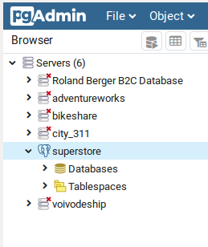

Follow the instructions to reveal the list of data tables.

* + Within “servers”
  + Click “superstore”
  + Click “Databases”
  + Click “superstore”: the tree structure will automatically expand to the following:  
    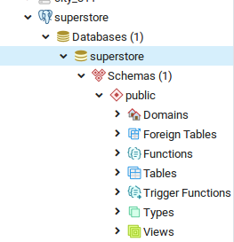
  + Click “Tables”.
    - You can now right-click an individual table and choose “View/Edit Data” to view the contents of that table.

#### Local Troubleshooting

If you have already had your students install PGAdmin locally and are pointing to a SQL database that no longer exists or fails to connect, you can make the following change to get reconnected:

1. In the server list on the left hand side, right-click the server that no longer connects and select “Properties”:  
   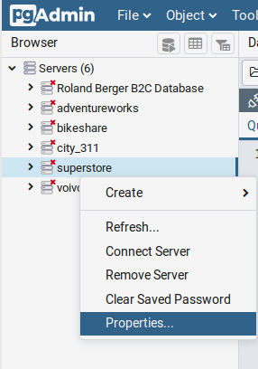
2. Under the “Connection” tab in the properties dialog, replace the contents of the “Host name/address” section with the following: **analyticsga-psql.generalassemb.ly**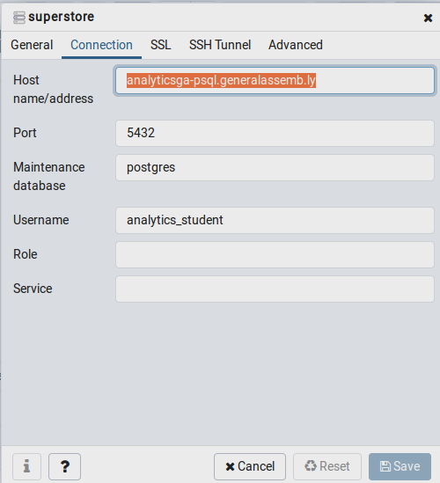
3. Click “Save”. You can now resume use of the database as before.